Report nº 01.01

Gửi đến: | Đoàn Hiệp, Moderateurs
Nội dung: | Thư viện PVNmcuPIC3
 | MICROSOFT WORD

Tóm tắt:
Báo cáo kết quả tạo thư viện linh kiện Microchip PIC 28, 40 và 44 chân.

- Danh sách linh kiện trong thư viện PVNmcuPIC3
  - Loại 28 chân
PIC16C55  PIC16C55-S  PIC16C57  PIC16C57-S  PIC16CR57  PIC16CR57-S  PIC16C62B-S  PIC16C72A-S  PIC16C63A-S  PIC16C73B-S  PIC16C62-S  PIC16C62A-S  PIC16CR62-S  PIC16C63-S  PIC16CR63-S  PIC16C66-S  PIC16C72-S  PIC16CR72-S  PIC18F2420  PIC18F2420-S  PIC18F2520  PIC18F2520-S  PIC18F2525  PIC18F2620 | PIC16C745-S  PIC16C773-S  PIC16F57  PIC16F57-S  PIC16F72  PIC16F72-S  PIC16F73  PIC16F73-S  PIC16F76  PIC16F76-S  PIC16F737  PIC16F737-S  PIC16F767  PIC16F767-S  PIC16F870  PIC16F872  PIC16F873A  PIC16F873A-S  PIC18F2X1X  PIC18F2410-S  PIC18F2510-S | PIC16F876A  PIC16F876A-S  PIC16F913  PIC16F913-S  PIC16F916  PIC16F916-S  PIC18F2220  PIC18F2320  PIC18F2221  PIC18F2221-S  PIC18F2321  PIC18F2321-S  PIC18F2331-S  PIC18F2431-S  PIC18F24J10  PIC18F24J10-S  PIC18F25J10  PIC18F25J10-S  PIC18F2455  PIC18F2550  PIC18F2480  PIC18F2480-S  PIC18F2580  PIC18F2580-S

  - Loại 40 chân
PIC16C64  PIC16C64-S  PIC16C64A  PIC16C64A-S  PIC16CR64  PIC16C65  PIC16C65A  PIC16C65A-S  PIC16CR65  PIC16CR65-S  PIC16C67 | PIC16C67-S  PIC16C65B  PIC16C65B-PLCC  PIC16C65B-S  PIC16C74B  PIC16C74B-PLCC  PIC16C74B-S  PIC16C774  PIC16C774-PLCC  PIC16C774-S  PIC16C74  PIC16C77 | PIC16C765  PIC16C765-PLCC  PIC16C765-S  PIC16F59  PIC16F59-S  PIC16F914  PIC16F914-Q  PIC16F914-S  PIC16F917  PIC16F917-Q  PIC16F917-S

  - Loại 44 chân
PIC16F74  PIC16F74-PLCC  PIC16F74-S  PIC16F77  PIC16F77-PLCC  PIC16F77-S  PIC16F747  PIC16F747-S  PIC18F4220  PIC18F4220-S  PIC18F4220-Q  PIC18F4320  PIC18F4320-S  PIC18F4320-Q  PIC18F44J10  PIC18F44J10-S  PIC18F44J10-Q  PIC18F45J10  PIC18F45J10-S  PIC18F45J10-Q | PIC16F747-Q  PIC16F777  PIC16F777-S  PIC16F777-Q  PIC16F871  PIC16F871-PLCC  PIC16F871-S  PIC18F4221  PIC18F4221-S  PIC18F4221-Q  PIC18F4321  PIC18F4321-S  PIC18F4321-Q | PIC16F874A  PIC16F874A-PLCC  PIC16F874A-S  PIC16F874A-Q  PIC16F877A  PIC16F877A-PLCC  PIC16F877A-S  PIC16F877A-Q  PIC18F4331  PIC18F4331-S  PIC18F4331-Q  PIC18F4431  PIC18F4431-S  PIC18F4431-Q

- Mẫu linh kiện
  - Loại 28 chân
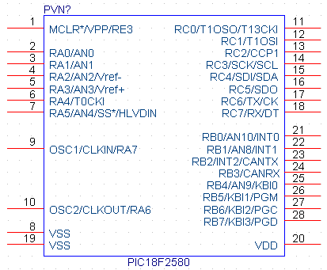
Hình 1.1: Linh kiện mẫu loại 28 chân PIC18F2580
  - Loại 40 chân
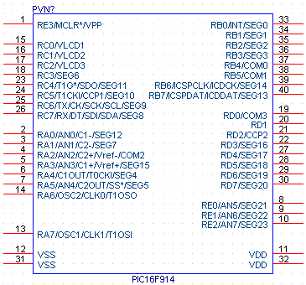
Hình 1.2: Linh kiện mẫu loại 40 chân PIC16F914

  - Loại 44 chân
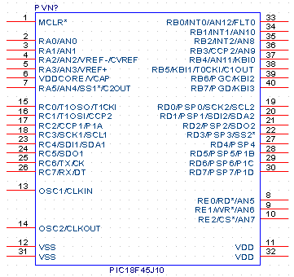
Hình 1.3: Linh kiện mẫu loại 44 chân PIC18F45J10

